Centre-scoped patient linkage with separately derived hub pseudonyms
Hypothesis. New hash-based patient imports can share a centre-scoped local UUID across authorised source machines while the hub receives a separately derived pseudonym. This preserves controlled longitudinal association without transmitting local identity hashes, local UUIDs or secret keys; it does not establish anonymity or prevent attribution using auxiliary information.
Revision of 23 October 2026. This revision documents deterministic local patient UUIDv8 generation. Historical experiments and the unchanged Lean listing remain dated to their original execution; current scope and evidence are maintained in feature-tracking/HubTransfer.yml.
Abstract
Background: Longitudinal endoscopy research requires record linkage, yet stable identifiers remain pseudonyms. Independently generated random patient UUIDs previously prevented machines with the same patient hash and centre context from deriving the same hub patient pseudonym.
Objective: To support centre-wide linkage of new hash-based patient imports using a keyed local UUIDv8, retain a separate target-hub pseudonym, and state the limits of this design under the General Data Protection Regulation (GDPR).
Methods: A new local patient UUIDv8 is derived by HMAC-SHA-256 from a purpose label, centre key and patient hash under the validated identity secret. Hub pseudonyms retain the separate HMAC over record kind, local UUID and target-hub key. We distinguish current regression tests from historical key-exposure experiments and 13 theorems in an unchanged Lean 4.19.0 supplement.
Results: Equal patient hashes, centre keys and secret generations produce equal local UUIDs and, for the same hub inputs, equal hub pseudonyms. Existing UUIDs and historical aliases are preserved; concurrent creation is serialised per centre. The selected verification covered 87 tests across the initial run and a corrected test-file rerun. Historical attack results and formal propositions are reported separately, not as a security proof of the new composition.
Conclusion: Deterministic centre-scoped UUIDs support association for newly imported identities. They do not make data universally anonymous. A hub recipient demonstrably lacking reasonably likely means of identification may receive non-personal data; site processing and disclosure still require their own lawful basis. This is a conditional legal argument, not a finding about the deployed hub.
Keywords: endoscopy; record linkage; pseudonymization; keyed hashing; data protection; formal verification
1. Introduction
Curated endoscopic media and reusable, documented datasets support research on findings, interventions and outcomes [1–3]. Register studies additionally require that follow-up examinations remain attributable to one patient after pseudonymization, and the same associations permit attribution through linkage with additional information [4,5].
Privacy-preserving record linkage compares encoded identifiers without revealing plaintext [6–8], but deterministic encodings of low-entropy demographics can be enumerated once their key is known [9], and even random identifiers become stable linkage keys once they cross an organizational boundary. Medical-research guidance therefore separates identifying and clinical data across roles [10].
We study a multi-site endoscopy registry in which a centre retains an identity secret and transfers processed media and structured metadata to a central hub. The revision adds deterministic patient UUIDs for new hash-based imports, retains separate hub derivation, and distinguishes functional linkage guarantees from cryptographic, identity-assurance and legal claims.
2. Design
2.1. Identifier inventory
Table 1 distinguishes the earlier transfer of random local UUIDs from the revised local patient derivation. The historical before/after column concerns disclosure to the hub, not a migration of existing records. Existing local UUIDs remain stable; only new hash-based patient imports use the new derivation.
Table 1. Patient-related identifiers in the site-to-hub transfer path.
Identifier | Derivation | Held by | Reaches hub (before → after)
Name, date of birth | Source data; deleted after review | Site | No → No
Patient / examination hash | HMAC-SHA-256 under local salt | Site | No → No
Identity salt | Local keyring | Site | No → No
Local patient / examination UUID | New hash-based patient: keyed UUIDv8, Eq. (2); existing and other paths unchanged | Site | Yes → No
Hub pseudonym | Equation (1) | Hub | — → Yes
Media content hash | SHA-256 of bytes | Site, hub | Yes → Yes
2.2. Salt-bound hub pseudonyms
For a local record with UUID u of kind κ, target hub key h and local salt s, the site sends
ψ(s, κ, u, h) = UUIDv8( HMAC-SHA-256_s( J(σ, κ, u, h) ) )(1)
Here σ = "hub-record-pseudonym-v1" and J is compact JSON encoded as UTF-8 with ensure_ascii=False. UUIDv8 takes the first 128 digest bits and sets the version and variant, leaving 122 digest bits [11,12]. Existing follow-ups resolve through the local patient-hash lookup. The target-hub key separates hub contexts. UUIDv8 validation checks format only: it cannot distinguish the new local UUIDv8 from a correctly derived hub pseudonym. Senders must always apply ψ.
For a new hash-based patient import with patient hash t, canonical centre key c and validated secret s, the local identifier is
λ(s, c, t) = UUIDv8(HMAC-SHA-256_s(J("center-patient-uuid-v1", c.strip(), t))) (2)
The exact patient-hash string is retained, including supported nonblank legacy values. Equal t, c and s produce equal λ across source machines; patient ψ also agrees when the target hub and hub-derivation key agree. This is centre-scoped, not global person identification. Examination UUIDs are unchanged. Existing patient UUIDs and historical aliases take precedence; direct ORM creation outside the hash-based import path keeps its previous default. No backfill is performed.
The identity salt is a high-entropy secret used as an HMAC key, not a public salt. Purpose labels separate local-patient and hub derivations, but reusing the same secret does not create independent compromise boundaries. Anyone with the relevant secret and a feasible candidate corpus may evaluate the entire composition for newly created patients. Legacy hash generation must also agree across machines; a hash containing a machine-local database identifier prevents convergence.
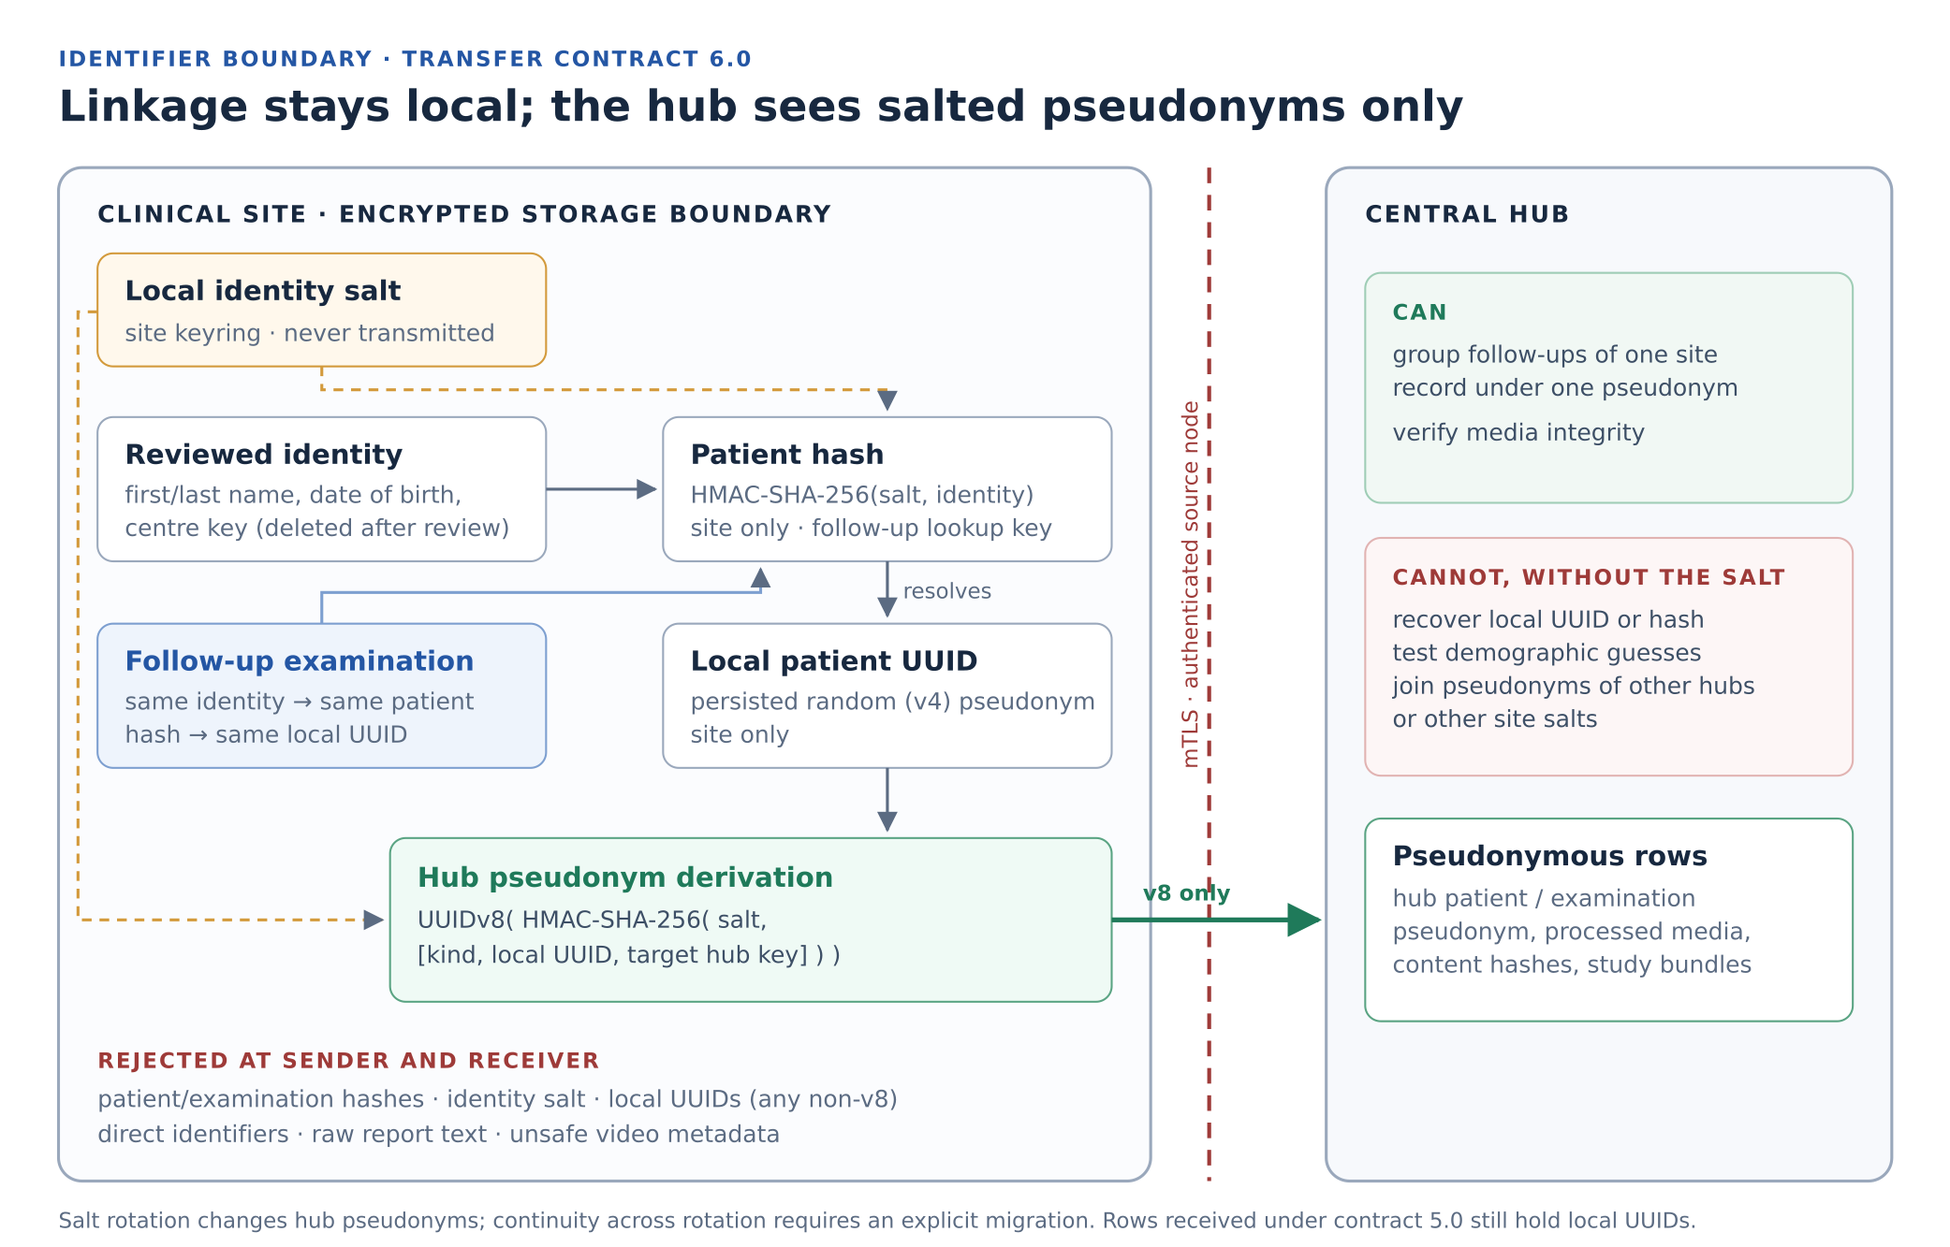
Figure 1. Historical contract-6.0 boundary diagram (22 October 2026). The random-v4 local-patient box is superseded for new hash-based imports by Equation (2); version checks no longer exclude every local UUID. The key-based statements assume no additional attribution information. Patient hashes, local UUIDs and secrets remain source-side; hub association is intentional.
3. Evaluation
3.1. Boundary enforcement
Historical contract, receiver and sender results are retained in Table S1 with their execution date. The 23 October extension was checked for deterministic derivation, centre/key separation, unchanged hub vectors, existing UUID and alias preservation, import reuse and concurrent patient creation (S1.8). Version-4 local IDs are still rejected by the transfer schema; local UUIDv8 exclusion depends on correct sender derivation, not version validation alone.
3.2. Effect of local keys under key exposure
A sandboxed attacker received unlabelled hash, local UUIDv8 or hub UUIDv8 rows from two synthetic centres (432 target rows per condition over three trials), an independent synthetic person corpus and the key specified by each condition. Target UUIDs were generated by production helpers; the isolated attacker independently evaluated patient hash → local UUIDv8 → hub UUIDv8. The hub context was known except in the wrong-hub control. Table 2 records the new measured results and repeated hash controls.
Table 2. Additional identity assignments after key exposure: current UUID mapping and repeated hash controls, 23 October 2026. Sums across three synthetic trials per condition; not population estimates. Slash-separated controls were measured separately, not pooled.
Mapping and exposure condition | Token matches | New correct mappings | False mappings
Hash control: Shared key of both centres | 192 | 144 | 12
Hash control: Independent local key of one centre | 96 | 72 | 6
Hash control: Wrong key | 0 | 0 | 0
Hash control: Shared key, rows already labelled (control) | 192 | 0 | 0
Current local UUIDv8; shared key exposed | 192 | 144 | 12
Current hub UUIDv8; shared key exposed | 192 | 144 | 12
Current local UUIDv8; one independent centre key exposed | 96 | 72 | 6
Current hub UUIDv8; one independent centre key exposed | 96 | 72 | 6
Current local UUIDv8; no key / wrong key (separate controls) | 0 | 0 | 0
Current hub UUIDv8; no key / wrong key / wrong hub (separate controls) | 0 | 0 | 0
Current local UUIDv8; shared key, rows already labelled | 192 | 0 | 0
Current hub UUIDv8; shared key, rows already labelled | 192 | 0 | 0
The current local and hub UUID mappings each produced 192 token matches, 144 additional correct assignments and 12 false assignments with the shared identity key exposed. One independent centre key gave 96, 72 and 6. The same key enables all three deterministic stages, so no local UUID table is required for candidate testing in this model. False assignments reflect incomplete auxiliary knowledge about people with identical demographics. No-key and wrong-key controls gave zero; this is not proof of anonymity against other auxiliary information. Newly created identities under each key generation were tested, not historical random UUIDs or rotation of already persisted identifiers. All 45 cases were replayed and independently rescored, with matching outcomes excluding timing and memory. Evidence: scripts/reidentification/evidence/uuid_mapping/; method and limits: scripts/reidentification/REPORT.md. Deleting original metadata or adding a keyed transform does not itself establish irreversible anonymisation.
3.3. Formal properties
Proposition 6 establishes equal hub outputs for equal inputs to a fixed local lookup. Proposition 7 rules out a universal recovery rule only under its explicit key-coverage premise. Neither proposition proves computational security of HMAC or of the new patient-hash → local-UUID → hub-pseudonym composition; the listing has not been extended or rerun for this revision.
In a Lean 4.19.0 model with abstract keyed functions [13], 13 theorems check using only Lean's standard axioms (Supplements S5–S6). Our results establish that a fingerprint match implies equal encodings or a collision, that equal demographics of distinct persons cannot be separated by any fingerprint, that fingerprints do not bind record UUIDs, and that an exact disclosed match reveals membership.
4. Discussion
The design separates association utility, protection of source-held identifiers, and assurance that two records denote the same human. Centre-wide consistency requires the same exact patient hash, canonical centre key and secret generation. It does not prove human identity: distinct people with identical encoded demographics remain indistinguishable. A shared secret expands exposure to every authorised machine holding it; separation between centres depends on their actual key administration and context, not machine count.
Local identifiers remain personal data for sites holding attribution information. Hub-derived identifiers are pseudonyms by construction; whether the received dataset is personal for a particular recipient requires a separate identifiability assessment. The January 2025 EDPB consultation guidance [30] is read alongside the later EDPS v SRB judgment [14]. Sections 4.1–4.2 state the German health-data grounds and the recipient-relative argument without assuming that a UUID algorithm alone establishes either lawfulness or anonymity.
4.1. Why the design can support lawful health-data processing in Germany
Deployment facts supplied for this revision are Germany, use for both patient care and scientific research, and a controller agreement requiring site-local pseudonym storage, retained linkage and no export of reversible pseudonyms. The agreement itself has not been inspected. These facts support the separation design; they do not identify the applicable statutory basis or establish compliance of every processing operation.
Care and research must be assessed separately. Personal health-data processing requires an Article 6 basis and an Article 9(2) exception. Necessary care may use Article 9(2)(h), subject to professional secrecy under Article 9(3), with an applicable Article 6 ground. Research may rely on valid explicit consent, or Article 9(2)(j) with applicable legislation and a separate Article 6 ground. A care basis does not automatically authorise hub research. Articles 25, 32 and 89 support safeguards; they are not independent permissions [17].
Where the BDSG applies, §22(1)(1)(b) supports necessary care processing under professional confidentiality, while §22(2) expressly includes access restrictions, pseudonymisation and encryption as safeguards [31]. For research without consent, §27(1) requires necessity and a substantial predominance of the controller’s research interests over exclusion interests. Section 27(3) requires anonymisation as soon as the research purpose permits, subject to legitimate interests of the person, and separate storage of attribution features until then [32]. Applicability depends on the institution and any governing Land, hospital or sector-specific law; the conditions cannot be inferred from a controller agreement.
The concrete necessity argument is that repeated examinations must be associated to evaluate longitudinal outcomes without disclosing identity inputs to the research recipient. Centre-scoped local derivation and separate hub derivation support that purpose. Determinism is an implementation choice, not proof that unrestricted centre-wide linkage is necessary. Care and research access should remain purpose-separated; a narrower study-specific scope should be used where sufficient. Retaining linkage indefinitely or across unrelated projects is not justified by the present research objective.
The reported agreement provides an organisational basis for keeping local mappings and secrets at sites. Actual roles determine whether Article 26 joint controllership or Article 28 processing arrangements apply [17,20]. Its “reversible pseudonyms” restriction must be interpreted operationally: absence of decryption does not exclude candidate matching, access through a site, or attribution from clinical content. Hub-specific keyed outputs support the intended separation only if those routes are effectively controlled. The agreement cannot replace the care/research legal grounds.
4.2. Recipient-relative non-personal data: the hub argument
EDPS v SRB (C-413/23 P, 4 September 2025) interprets Regulation (EU) 2018/1725, whose identifiability reasoning is relevant to GDPR Article 4(1) and recital 26. Pseudonymised data need not be personal for every recipient. Under paragraphs 75–87, effective measures must prevent the recipient from lifting the separation or identifying people through other reasonably likely means, including cross-checking. Site-held additional information alone does not settle the recipient’s position. Paragraphs 100–115 preserve the originating controller’s information duties. This is a recipient-relative assessment, not a new statutory exemption [14].
Applied to the stated design, the affirmative argument is: the sites retain patient hashes, local UUID mappings and secret keys; the hub receives only separately derived identifiers and minimised clinical resources; enforceable arrangements and technical separation deny the hub reasonably likely access to identifying information. If those premises hold for the actual recipient and complete dataset, the data may be non-personal for that hub recipient despite remaining personal for the sites. This inference explains why site-side longitudinal linkage need not preclude recipient-relative anonymity; it does not establish the premises from source code alone.
The assessment concerns the real receiving entity and processing context, not merely a default account permission. For this dual-use hub it must include care workflows, shared administrators, backups, site-query interfaces, available legal or practical access routes, and linkage using dates, rare diagnoses, images or released artifact equality. A research user’s restricted login does not itself make data non-personal for an organisation that can identify patients elsewhere. Separate research processing can support the argument only where effective separation exists. Until demonstrated, the manuscript treats hub data as protected health data operationally. Onward disclosure requires a recipient-specific reassessment [14].
Accordingly, the defensible conclusion is conditional permission for necessary, lawfully based care/research linkage, together with a recipient-relative non-personal-data argument for a demonstrably separated hub recipient. It is not permission derived from a shared secret, a controller agreement or the UUIDv8 format alone. The identified legal ground, separation evidence and scope of longitudinal use belong in the controller’s assessment.
Limitations. The receiver cannot verify ψ from UUID version alone. Deterministic patient UUIDs remove the previous random-input barrier to demographic candidate testing after key compromise. UUID formatting retains 122 digest bits and does not eliminate collisions. Existing independently created patients do not converge automatically; rotation and legacy hub rows require explicit reconciliation. The historic Lean model is not a computational security proof for the composition. Synthetic experiments do not estimate clinical linkage or re-identification rates [21,22]. Evidence obligations remain in the feature tracker.
5. Conclusion
New hash-based patient imports can obtain consistent local UUIDv8 values within a centre; the hub receives separately derived pseudonyms. Existing identities remain stable. The German care/research framework can support lawful linkage where its statutory conditions and safeguards are met. Recipient-relative non-personal status is a separate, fact-dependent argument for a hub unable to identify patients, not an inherent UUID property or an exemption for the originating sites. Functional tests and historical proofs do not decide that legal classification.
Data and code availability
Source code [23,24], the Lean supplement (SHA-256 bc38dc5e…6cfede) and the key-exposure archive (SHA-256 87e7c007…5790f2c) are identified in Supplement S7 and the evidence references R1–R11.
References
1. Borgli H, Thambawita V, Smedsrud PH, et al. HyperKvasir, a comprehensive multi-class image and video dataset for gastrointestinal endoscopy. Scientific Data. 2020;7:283. doi:10.1038/s41597-020-00622-y
2. Wilkinson MD, Dumontier M, Aalbersberg IJJ, et al. The FAIR Guiding Principles for scientific data management and stewardship. Scientific Data. 2016;3:160018. doi:10.1038/sdata.2016.18
3. Gebru T, Morgenstern J, Vecchione B, et al. Datasheets for datasets. Communications of the ACM. 2021;64(12):86–92. doi:10.1145/3458723
4. Gadotti A, Rocher L, Houssiau F, Creţu AM, de Montjoye YA. Anonymization: The imperfect science of using data while preserving privacy. Science Advances. 2024;10(29):eadn7053. doi:10.1126/sciadv.adn7053
5. Rocher L, Hendrickx JM, de Montjoye YA. Estimating the success of re-identifications in incomplete datasets using generative models. Nature Communications. 2019;10:3069. doi:10.1038/s41467-019-10933-3
6. Schnell R, Bachteler T, Reiher J. Privacy-preserving record linkage using Bloom filters. BMC Medical Informatics and Decision Making. 2009;9:41. doi:10.1186/1472-6947-9-41
7. Vatsalan D, Christen P, Verykios VS. A taxonomy of privacy-preserving record linkage techniques. Information Systems. 2013;38(6):946–969. doi:10.1016/j.is.2012.11.005
8. Christen P, Ranbaduge T, Schnell R. Linking Sensitive Data: Methods and Techniques for Practical Privacy-Preserving Information Sharing. Springer; 2020. doi:10.1007/978-3-030-59706-1
9. Kuzu M, Kantarcioglu M, Durham E, Malin B. A constraint satisfaction cryptanalysis of Bloom filters in private record linkage. In: Privacy Enhancing Technologies (PETS 2011). LNCS 6794. Springer; 2011. p. 226–245. doi:10.1007/978-3-642-22263-4_13
10. Pommerening K, Drepper J, Helbing K, Ganslandt T. Leitfaden zum Datenschutz in medizinischen Forschungsprojekten: Generische Lösungen der TMF 2.0. Berlin: MWV; 2014. ISBN 978-3-95466-123-8.
11. Krawczyk H, Bellare M, Canetti R. HMAC: Keyed-hashing for message authentication. RFC 2104. February 1997. doi:10.17487/RFC2104
12. Davis K, Peabody B, Leach P. Universally Unique IDentifiers (UUIDs). RFC 9562. May 2024. doi:10.17487/RFC9562
13. de Moura L, Ullrich S. The Lean 4 theorem prover and programming language. In: Automated Deduction – CADE 28. LNCS 12699. Springer; 2021. p. 625–635. doi:10.1007/978-3-030-79876-5_37
14. Court of Justice of the European Union. EDPS v SRB (Concept of personal data). Judgment of 4 September 2025, C-413/23 P. ECLI:EU:C:2025:645. Paragraphs 52, 75–87 and 102–115. Source.
15. Article 29 Data Protection Working Party. Opinion 05/2014 on Anonymisation Techniques. WP216. Adopted 10 April 2014. Source.
16. European Data Protection Board. Guidelines 02/2026 on Anonymisation. Version 1.0, adopted 7 July 2026 for public consultation; sections 2–3. Status checked 14 October 2026. Source.
17. European Parliament and Council of the European Union. Regulation (EU) 2016/679 (General Data Protection Regulation). Official Journal of the European Union. 2016;L119:1–88. Source.
18. European Data Protection Board. Guidelines 4/2019 on Article 25 Data Protection by Design and by Default. Version 2.0, adopted 20 October 2020. Source.
19. European Data Protection Board. Guidelines 1/2026 on processing of personal data for scientific research purposes. Adopted 15 April 2026; consultation version, status checked 14 October 2026. Source.
20. European Data Protection Board. Guidelines 07/2020 on the concepts of controller and processor in the GDPR. Version 2.1, corrected 20 September 2022. Source.
21. Bellare M. New proofs for NMAC and HMAC: Security without collision resistance. Journal of Cryptology. 2015;28(4):844–878. doi:10.1007/s00145-014-9185-x
22. Harron KL, Doidge JC, Knight HE, et al. A guide to evaluating linkage quality for the analysis of linked data. International Journal of Epidemiology. 2017;46(5):1699–1710. doi:10.1093/ije/dyx177
23. endoreg-db contributors. endoreg-db source code. Prototype implementation snapshot a965c67454013a92a95470e533a7f38a40ef4ddd. Inspected 20 and 22 October 2026. Source.
24. lx-data-models contributors. Hub transfer and study exchange contracts. lx_dtypes/models/contracts/hub_transfer.py. Source.
25. Dolstra E, Löh A. NixOS: A purely functional Linux distribution. Proceedings of ICFP 2008. 2008. p. 367–378. doi:10.1145/1411204.1411255
26. Bourguet ML. How finite state machines can be used to build error free multimodal interaction systems. Proceedings of HCI 2003. Vol. 2. 2003. p. 81–84.
27. Wasserman AI. Extending state transition diagrams for the specification of human–computer interaction. IEEE Transactions on Software Engineering. 1985;SE-11(8):699–713. doi:10.1109/TSE.1985.232519
28. Keller M. MP-SPDZ: A versatile framework for multi-party computation. In: Proceedings of ACM CCS 2020. p. 1575–1590. doi:10.1145/3372297.3417872
30. European Data Protection Board. Guidelines 01/2025 on Pseudonymisation. Adopted 16 January 2025; version for public consultation. Sections 3.1–3.3, especially paragraphs 88–89, 107–109 and 115–125. https://www.edpb.europa.eu/system/files/2025-01/edpb_guidelines_202501_pseudonymisation_en.pdf
31. Bundesdatenschutzgesetz (BDSG), §22, Verarbeitung besonderer Kategorien personenbezogener Daten. Current statutory text consulted 23 October 2026. https://www.gesetze-im-internet.de/bdsg_2018/__22.html
32. Bundesdatenschutzgesetz (BDSG), §27, Datenverarbeitung zu wissenschaftlichen oder historischen Forschungszwecken und zu statistischen Zwecken. Current statutory text consulted 23 October 2026. https://www.gesetze-im-internet.de/bdsg_2018/__27.html
29. Davidson A, Faz-Hernandez A, Sullivan N, Wood CA. Oblivious pseudorandom functions (OPRFs) using prime-order groups. RFC 9497. December 2023. doi:10.17487/RFC9497

Supplement S1. Hub pseudonyms and the local UUIDv8 extension
S1.1. Software setting
LX-Annotate provides the site interface and orchestration; endoreg-db supplies domain models and processing services; lx-data-models defines shared typed contracts. LuxNix, an adaptation of NixOS, provisions hosts [25]. Review gates and recovery transitions follow a finite-state design [26,27] (Figure S1).
S1.2. Production encoding
get_hub_record_pseudonym(record_uuid, kind, hub_node_key, salt) in endoreg_db/utils/hashs.py serializes ["hub-record-pseudonym-v1", kind, str(record_uuid), hub_node_key.strip()] as compact JSON with ensure_ascii=False, encodes it as UTF-8, computes HMAC-SHA-256 under the active (or an explicitly enrolled historical) identity salt, keeps the first 16 bytes and sets the version nibble to 8 and the variant bits to 10. Empty hub keys are rejected. endoreg_db/services/hub/hub_pseudonyms.py applies it to media identity rows and study bundles [R10].
S1.3. Fail-closed enforcement
The historical contract-6.0 tests required UUIDv8 in patient/examination identity rows and study links, rejecting the then-local UUIDv4 values. The current documented transfer contract is 7.0; the separate hub derivation is unchanged. New local patient UUIDs can also be version 8, so version validation does not prove source transformation. The sender must derive ψ for every transfer; authenticated source ownership and receiver conflict checks remain separate controls [R6, R10, R12].
S1.4. Study bundles
The sender re-keys every patient and examination reference in study-exchange bundles with ψ before transfer, so hub-side study acceptance resolves to the pseudonymous rows created by media transfer. Version-pinned assessments are revalidated on the re-keyed bundle and remained unchanged in the tests.
S1.5. Operational consequences
- Salt rotation changes newly computed hub pseudonyms and newly computed local patient UUIDs. Existing persisted patient UUIDs are preserved and resolved through current or historical hashes. Cross-machine continuity across generations requires preserved mappings and, where necessary, an explicit hub reconciliation; recomputation alone does not supply it (hub_pseudonym_lifecycle).
- Hub rows received under contract 5.0 still hold local UUIDs and require a separate fail-closed reconciliation (same criterion).
- Shared contract, sender and receiver must be deployed together; mixed versions fail closed.
S1.6. Verification
Table S1. Verification of contract 6.0 on 22 October 2026 (working tree on a965c674; sibling sources via explicit path overlays).
Suite | Scope | Outcome
lx-data-models contract | Identity rows, study links, legacy rejection | 63 passed
endoreg-db identity, study, transfer | ψ unit tests, study re-keying, receiver boundary, migration | 136 passed, 3 subtests
endoreg-db HTTP receiver, registration | Hub transfer endpoints with v8 payloads | 64 passed, 35 subtests
LX-Annotate tests/hub | Sender payloads, guards, recovery, worker, end-to-end, study | 259 passed
Static checks | Pyright (endoreg-db, lx-data-models), Ruff, 66 structure maps | 0 errors; passed
S1.7. Private matching status
The guarded private-matching implementation uses MP-SPDZ [28]. At the reviewed working tree its input, acceptance, backend-adapter and workflow suites passed with 56 tests; eight native MP-SPDZ tests were skipped without an installed v0.4.4 tree and are not counted as cryptographic validation. Matching on verified issuer-qualified identifiers, for example via oblivious pseudorandom functions [29], remains a separate tracked criterion.
S1.8. Local patient UUIDv8 extension (23 October 2026)
get_patient_uuid(patient_hash, center_key, salt) in endoreg_db/utils/hashs.py implements Equation (2) through the existing validated identity-key helper and shared UUIDv8 formatter. Empty hashes and centre keys are rejected; invalid secrets fail as configuration errors. services/patient_identity/creation.py serialises resolution and insertion with a transaction and centre-row lock, preserving existing UUIDs and historical aliases. The preanonymized external-identity creation path also assigns this local UUID. Hub derivation, examination IDs and secret provisioning are unchanged.
The initial selected run reported 86 passed and one failed test that expected ValueError instead of the existing ImproperlyConfigured exception for an invalid secret. Correcting that assertion was followed by 11/11 passes in the new UUID file; the other 76 selected tests had passed unchanged. Coverage included fixed local/hub vectors, centre/key separation, concurrent creation, historical aliases, patient imports, external IDs and hub pseudonyms. Focused Pyright and Ruff passed; 67 structure maps and 38 feature definitions validated. Full-repository Pyright retained an unrelated private-import error in tests/views/test_central_hub_training_access.py:311. These are working-tree observations, not a pinned release or production-readiness claim [R12].
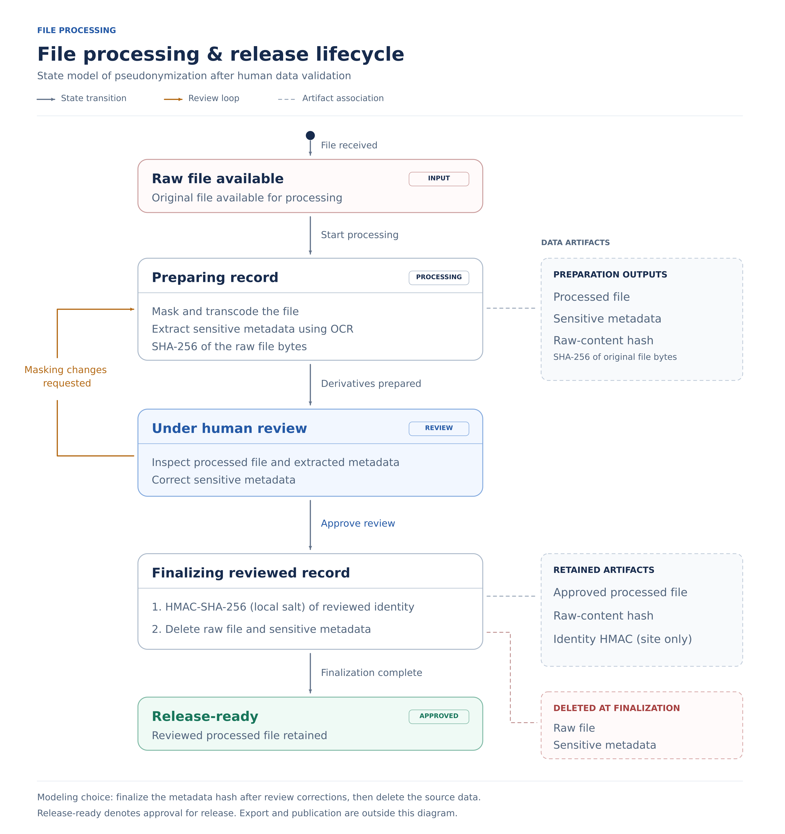
Figure S1. Historical processing/release model. Retention and deletion remain subject to the operational validation gates; deletion is not evidence of anonymity. The new local UUID derivation occurs during hash-based patient creation and is not depicted here.
Supplement S2. Artifact identity experiment
RGB baselines with bytes cycling modulo 251 at 8 × 8 and 16 × 16 pixels were perturbed one channel intensity unit at a time and restored, giving six trajectories, identical-copy controls and a metadata-only change [R2]. Content hashes discriminate encoded bytes including metadata, not visual content; unchanged artifacts remain linkable by equality across releases, independently of patient pseudonyms.
Table S2. Artifact observations (historical execution; not rerun).
Observation class | Count | Outcome
Forward changes: 3 × (64 + 256) | 960 | 0 baseline matches; no repeated forward digest
Reverse steps | 960 | 960 earlier-state matches
Identical-copy controls | 6 | 6 baseline matches
Metadata-only change | 1 | 0 baseline matches; pixels unchanged
Baselines | 7 | Reference observations
Total | 1,934 | Seven recorded tests passed
Supplement S3. Threat model
Parties are a clinical centre and its authorised source machines (identity inputs, secret and mappings), a hub (approved processed resources), a peer participating in private matching, and recipients with auxiliary information. Compromise of a shared centre secret can enable candidate testing across new patient UUIDs and hub pseudonyms; the relevant input context and key generations matter. Access to original records or mappings also permits attribution. Host separation does not imply independent administration.
Table S3. Conditional pathways, not calibrated severity scores.
Pathway | Evidence or condition | Interpretation
Hub accumulates one patient's records | Contract 6.0 sends salt-bound pseudonyms | Association is intentional; attribution may also use auxiliary data.
Hub tries to recover local identifiers | Proposition 7 is conditional; new patient inputs are deterministic. | No computational security proof; exposed keys permit candidate testing.
Recipient compares artifact digests | 6/6 copies match; 1/1 metadata edit differs | Equality links unchanged artifacts.
Attacker holds key and hash dump | Table 2: 144 vs 72 new mappings | Key scope bounds exposure.
Sender substitutes ownership fields | Authenticated ownership checks; v8 is only a format check. | Depends on authenticated principals.
Administrator obtains keys or state | Endpoint, backup, logging assumptions | Host compromise exceeds protocol outputs.
Adaptive matching queries | Each result conveys membership | Replay protection does not bound cumulative inference.
Supplement S4. Identity-key experiments
S4.1. Shared and local HMAC keys (historical)
The production helper fingerprinted Synthetic Person, born 1980-07-14, under centre-a; every date of leap year 1980 was enumerated (366 candidates, ten scans, five conditions). Conditions supplying A's key and context recovered exactly one candidate at position 196 in every repetition; the other three returned none. Median scan times were 6.19–6.27 ms on an Intel Core i5-12450H with Python 3.12.14 [R1, R3].
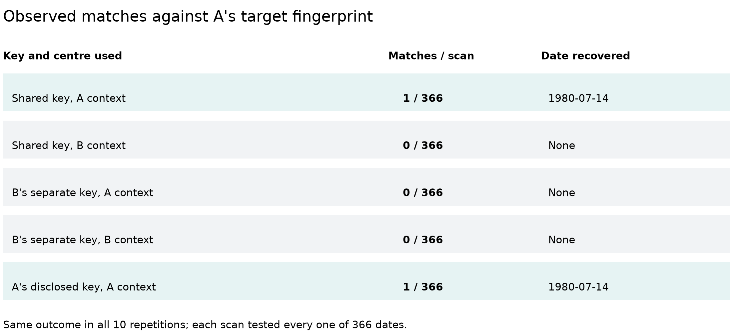
Figure S2. Match outcomes per condition; all ten repetitions agreed.
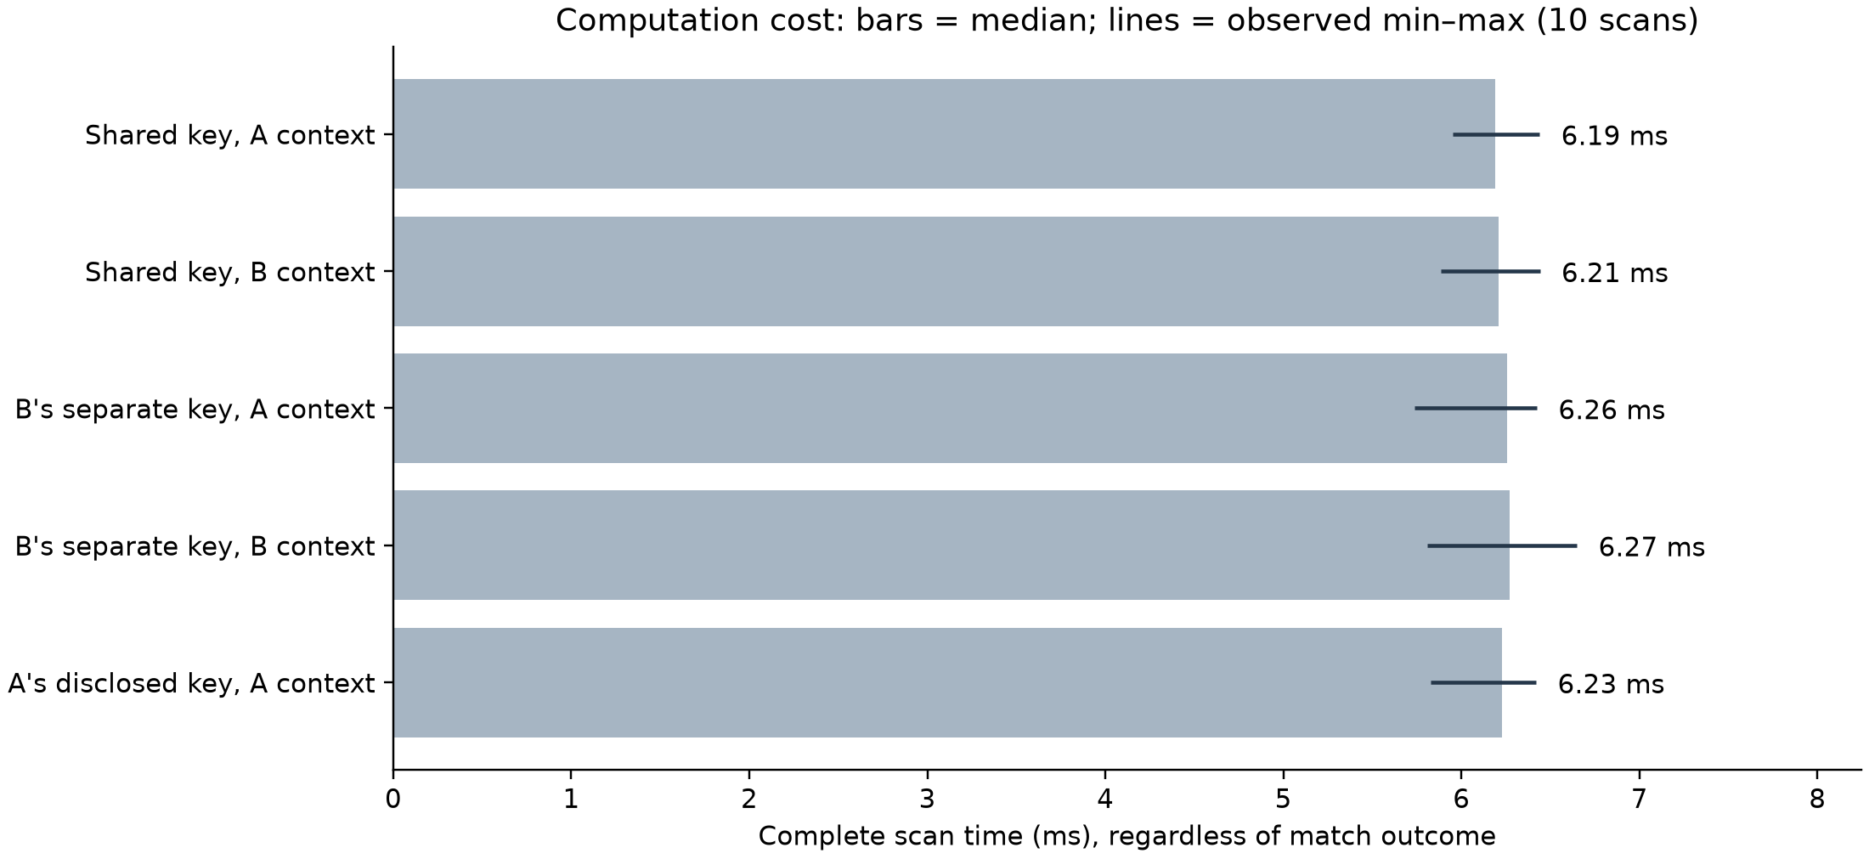
Figure S3. Cost of a complete scan; bars show medians, lines the observed range.
S4.2. Key-exposure experiment
Workers received only typed input bundles under Linux Landlock with file reads denied before processing; an independent rescorer reproduced all 48 case outcomes. Each trial contained 18 synthetic persons with two records per centre and key generation, including three persons sharing one encoded tuple and a hidden twin. Membership claims are conditional on corpus uniqueness [R11].
Table S4. All conditions of the key-exposure experiment (sums over three trials, 432 target rows each).
Condition | Digest matches | New correct | False | Membership correct / false
Shared key, independent person corpus | 192 | 144 | 12 | 36 / 3
Independent key of one centre | 96 | 72 | 6 | 36 / 3
Retained historical key | 192 | 144 | 12 | 36 / 3
Wrong key | 0 | 0 | 0 | 0 / 0
Central oracle, 32 queries | 92 | 44 | 12 | 11 / 3
Broad prior, no person corpus | 84 | 0 | 0 | n/a
Fully labelled control | 192 | 0 | 0 | 0 / 0
Supplement S5. Mathematical formulation
Propositions 1–7 below correspond to the unchanged historical Lean listing. The interpretation of P3 and P6 is qualified for the new local UUID derivation; no new theorem about that composition is claimed. Cryptographic security, human identity and production enforcement remain outside the formal statements.
S5.1. Model
Let E : X × C → P encode a demographic tuple in a centre context, M : K × P → T be a keyed deterministic function and H : B → T an artifact digest. A source record A has label u_A, centre c_A, key k_A and target t_A with source binding t_A = M_{k_A}(E(x_A, c_A)); the comparison is Match_A(u, x) = [M_{k_A}(E(x, c_A)) = t_A]. For deterministic F, Coll_F(p, q) ⇔ p ≠ q ∧ F(p) = F(q).
S5.2. Propositions 1–5
P1. b = b′ ⇒ H(b) = H(b′), and H(b) = H(b′) ⇒ b = b′ ∨ Coll_H(b, b′). Lean: identical_input_equal_digest; digest_equality_or_collision.
P2. Under source binding, equal encodings match; a match implies equal encodings or a collision for that pair; without collision a match implies equal encodings, not the same person. Lean: equal_payload_matches; match_implies_equal_payload_or_collision; payload_equality_of_match_and_no_collision.
P3. Replacing candidate or source labels leaves Match_A unchanged because that comparison does not inspect labels. Lean: candidate_uuid_substitution; source_uuid_substitution. New local UUIDs are derived from patient hashes, but this does not make the separate matching predicate authenticate a submitted UUID-to-record binding; the original abstract theorem is unchanged.
P4. If distinct persons share an encoding, no fingerprint satisfies F(d(a)) = F(d(b)) ⇒ a = b. Lean: demographic_identifier_impossible.
P5. If a readable result is correct for every world and each of N > 0 execution choices, the reading distinguisher accepts N choices in a member world and 0 in a non-member world, so membership cannot be perfectly hidden. Lean: exact_membership_distinguishes; exact_membership_cannot_be_perfectly_hidden; acceptanceCount_of_constant.
S5.3. Proposition 6 — Local follow-ups keep one hub pseudonym
For deterministic ψ and a fixed lookup ρ, t₁ = t₂ implies ψ(s, κ, ρ(t₁), h) = ψ(s, κ, ρ(t₂), h). Lean: followup_keeps_hub_pseudonym. The new creation rule instantiates ρ(t) using Equation (2) only for new imports under fixed centre/key inputs; existing rows and aliases take precedence. Equal inputs across machines give equal outputs by determinism, not by a newly checked theorem. Equal hashes do not establish the same person (P4).
S5.4. Proposition 7 — The hub view does not determine the local UUID
Under key coverage for κ and h—every output is reachable from every local UUID under some salt—no rec satisfies rec(ψ(s, κ, u, h)) = u for all s,u. The existing proof chooses a common output for labels 0 and 1. Lean: hub_view_does_not_determine_local_uuid. Coverage is an explicit abstract premise, not a verified HMAC property. In the new composition u itself depends on s and the patient hash, so this theorem must not be read as a proof for that dependent distribution or as protection after secret exposure.
Supplement S6. Lean formalization
Historical verification: LinkageSupplement.lean imports only Std and was checked with Lean 4.19.0 (commit 6caaee842e94) on 22 October 2026 with warnings as errors. The recorded audit of 13 theorems reported propext, Classical.choice and Quot.sound; five used no axioms. This revision preserves the listing and its recorded checksum byte-for-byte at the paragraph-content level; no new proof run or composition theorem is claimed.
lean -DwarningAsError=true LinkageSupplement.lean

Source SHA-256: bc38dc5e9f27997e9cb6bb5dcbd347204a95f0bb595129bc4561f4ef7d6cfede
Listing S1. Complete standalone formalization.
import Std

/-!
Supplement: functional linkage properties and disclosure limits.
Checked with Lean 4.19.0. Only `Std` is required.
`digest`, `mac`, `encode` and `pseudonym` are arbitrary deterministic functions.
They are not verified implementations of SHA-256, HMAC, Python JSON or UUIDv8.
The source-binding, exact-output and key-coverage hypotheses are explicit premises.
No cryptographic hardness or deployed-protocol security is asserted.
-/

set_option autoImplicit false

namespace LinkageSupplement

variable {Data Key Payload Tag : Type}

def Collision (digest : Payload → Tag) (x y : Payload) : Prop :=
x ≠ y ∧ digest x = digest y

-- Identical encoded artifacts have equal deterministic digests.
theorem identical_input_equal_digest (digest : Payload → Tag)
(x y : Payload) (same : x = y) : digest x = digest y :=
congrArg digest same

-- Digest equality alone is qualified by a possible collision.
theorem digest_equality_or_collision (digest : Payload → Tag)
(x y : Payload) (equalTags : digest x = digest y) :
x = y ∨ Collision digest x y := by
classical
by_cases same : x = y
· exact Or.inl same
· exact Or.inr ⟨same, equalTags⟩

structure Candidate (Data : Type) where
uuid : Nat
data : Data

structure Source (Key Tag : Type) where
uuid : Nat
center : String
key : Key
target : Tag

-- Every candidate is reconstructed in the source's key/centre context.
def matchCandidate [DecidableEq Tag]
(mac : Key → Payload → Tag) (encode : Data → String → Payload)
(source : Source Key Tag) (row : Candidate Data) : Bool :=
decide (mac source.key (encode row.data source.center) = source.target)

theorem equal_payload_matches [DecidableEq Tag]
(mac : Key → Payload → Tag) (encode : Data → String → Payload)
(source : Source Key Tag) (row : Candidate Data) (original : Data)
(bound : source.target = mac source.key (encode original source.center))
(same : encode row.data source.center = encode original source.center) :
matchCandidate mac encode source row = true := by
simp [matchCandidate, same, bound]

theorem match_implies_equal_payload_or_collision [DecidableEq Tag]
(mac : Key → Payload → Tag) (encode : Data → String → Payload)
(source : Source Key Tag) (row : Candidate Data) (original : Data)
(bound : source.target = mac source.key (encode original source.center))
(matched : matchCandidate mac encode source row = true) :
encode row.data source.center = encode original source.center ∨
Collision (mac source.key) (encode row.data source.center)
(encode original source.center) := by
have tagEq :
mac source.key (encode row.data source.center) = source.target := by
simpa [matchCandidate] using matched
exact digest_equality_or_collision (mac source.key)
(encode row.data source.center) (encode original source.center)
(tagEq.trans bound)

theorem payload_equality_of_match_and_no_collision [DecidableEq Tag]
(mac : Key → Payload → Tag) (encode : Data → String → Payload)
(source : Source Key Tag) (row : Candidate Data) (original : Data)
(bound : source.target = mac source.key (encode original source.center))
(matched : matchCandidate mac encode source row = true)
(noCollision : ¬ Collision (mac source.key)
(encode row.data source.center) (encode original source.center)) :
encode row.data source.center = encode original source.center := by
rcases match_implies_equal_payload_or_collision
mac encode source row original bound matched with same | collision
· exact same
· exact False.elim (noCollision collision)

theorem candidate_uuid_substitution [DecidableEq Tag]
(mac : Key → Payload → Tag) (encode : Data → String → Payload)
(source : Source Key Tag) (row : Candidate Data) (replacement : Nat) :
matchCandidate mac encode source { row with uuid := replacement } =
matchCandidate mac encode source row := rfl

theorem source_uuid_substitution [DecidableEq Tag]
(mac : Key → Payload → Tag) (encode : Data → String → Payload)
(source : Source Key Tag) (row : Candidate Data) (replacement : Nat) :
matchCandidate mac encode { source with uuid := replacement } row =
matchCandidate mac encode source row := rfl

-- This ambiguity is in the encoded demographics, not a hash collision.
theorem demographic_identifier_impossible {Person : Type}
(encodePerson : Person → Payload) (fingerprint : Payload → Tag)
(homonyms : ∃ p q : Person, p ≠ q ∧ encodePerson p = encodePerson q) :
¬ (∀ p q : Person,
fingerprint (encodePerson p) = fingerprint (encodePerson q) → p = q) := by
intro identifies
obtain ⟨p, q, different, sameEncoding⟩ := homonyms
exact different (identifies p q (congrArg fingerprint sameEncoding))

-- Fin N represents N equally likely random coins. Counts avoid rounding.
def acceptanceCount {View : Type} (readBit : View → Bool) :
(n : Nat) → (Fin n → View) → Nat
| 0, _ => 0
| n + 1, samples =>
(if readBit (samples 0) then 1 else 0) +
acceptanceCount readBit n (fun coin => samples coin.succ)

theorem acceptanceCount_of_constant {View : Type}
(readBit : View → Bool) (n : Nat) (samples : Fin n → View) (bit : Bool)
(constant : ∀ coin, readBit (samples coin) = bit) :
acceptanceCount readBit n samples = (if bit then n else 0) := by
induction n with
| zero => cases bit <;> rfl
| succ n ih =>
have tailConstant :
∀ coin : Fin n,
readBit ((fun i : Fin n => samples i.succ) coin) = bit :=
fun coin => constant coin.succ
have tailCount := ih (fun coin => samples coin.succ) tailConstant
simp only [acceptanceCount]
rw [constant 0, tailCount]
cases bit <;> simp [Nat.add_comm]

section Disclosure

variable {World View : Type}

-- A disclosed bit is assumed correct for every world and every coin.
def ExactMembershipOutput (n : Nat)
(view : World → Fin n → View) (membership : World → Bool)
(readOutput : View → Bool) : Prop :=
∀ world coin, readOutput (view world coin) = membership world

theorem exact_membership_distinguishes (n : Nat)
(view : World → Fin n → View) (membership : World → Bool)
(readOutput : View → Bool)
(correct : ExactMembershipOutput n view membership readOutput)
(yesWorld noWorld : World)
(isYes : membership yesWorld = true)
(isNo : membership noWorld = false) :
acceptanceCount readOutput n (view yesWorld) = n ∧
acceptanceCount readOutput n (view noWorld) = 0 := by
constructor
· have constant : ∀ coin, readOutput (view yesWorld coin) = true := by
intro coin
rw [correct yesWorld coin, isYes]
simpa using acceptanceCount_of_constant readOutput n
(view yesWorld) true constant
· have constant : ∀ coin, readOutput (view noWorld coin) = false := by
intro coin
rw [correct noWorld coin, isNo]
simpa using acceptanceCount_of_constant readOutput n
(view noWorld) false constant

-- A readable, exact result cannot itself have perfect membership privacy.
-- This says nothing about whether other private inputs remain protected.
theorem exact_membership_cannot_be_perfectly_hidden
(n : Nat) (nonempty : 0 < n)
(view : World → Fin n → View) (membership : World → Bool)
(readOutput : View → Bool)
(correct : ExactMembershipOutput n view membership readOutput)
(yesWorld noWorld : World)
(isYes : membership yesWorld = true)
(isNo : membership noWorld = false) :
¬ (∀ distinguish : View → Bool,
acceptanceCount distinguish n (view yesWorld) =
acceptanceCount distinguish n (view noWorld)) := by
intro hidden
have counts := exact_membership_distinguishes n view membership
readOutput correct yesWorld noWorld isYes isNo
have equalCounts := hidden readOutput
omega

end Disclosure

/-! Hub-scoped pseudonyms (contract 6.0).
`pseudonym salt kind localUuid hub` models the site-side keyed derivation;
`resolve` models the site's local patient-hash → local-UUID lookup. -/

section HubPseudonyms

variable {Salt Kind Hub Out Hash : Type}

-- Follow-ups resolved locally to the same patient keep one hub pseudonym.
theorem followup_keeps_hub_pseudonym
(pseudonym : Salt → Kind → Nat → Hub → Out) (resolve : Hash → Nat)
(salt : Salt) (kind : Kind) (hub : Hub) (first followUp : Hash)
(sameLocalHash : first = followUp) :
pseudonym salt kind (resolve first) hub =
pseudonym salt kind (resolve followUp) hub := by
rw [sameLocalHash]

/-- Key coverage: for this kind and hub, every output is reachable from every
local UUID under some salt. An ideal keyed function over a large key space
approximates this; HMAC-SHA-256 is not proved to satisfy it here. -/
def KeyCoverage (pseudonym : Salt → Kind → Nat → Hub → Out)
(kind : Kind) (hub : Hub) : Prop :=
∀ (uuid : Nat) (out : Out), ∃ salt, pseudonym salt kind uuid hub = out

-- Without the salt, no fixed rule recovers the local UUID from the hub view.
theorem hub_view_does_not_determine_local_uuid
(pseudonym : Salt → Kind → Nat → Hub → Out) (kind : Kind) (hub : Hub)
(coverage : KeyCoverage pseudonym kind hub) (someSalt : Salt) :
¬ ∃ recover : Out → Nat,
∀ salt uuid, recover (pseudonym salt kind uuid hub) = uuid := by
rintro ⟨recover, recovers⟩
obtain ⟨otherSalt, sameOut⟩ := coverage 1 (pseudonym someSalt kind 0 hub)
have viaZero := recovers someSalt 0
have viaOne := recovers otherSalt 1
rw [sameOut] at viaOne
omega

end HubPseudonyms

end LinkageSupplement

Supplement S7. Evidence provenance and tracker references
Table S5. Software version concerned by each result.
Evidence | Concerns | Executed
Artifact experiment (S2), HMAC scans (S4.1) | Evaluation designation 1.6.0 | Before 20 Oct 2026; not rerun
Key-exposure experiment (Table 2, S4.2) | a965c674 with recorded dirty state | 21 Oct 2026; replayed, rescored
Boundary tests (Table S1) | a965c674 + contract 6.0 working tree | 22 Oct 2026
Matching suites (S1.7) | a965c674 working tree | 22 Oct 2026
Lean supplement (S6) | Abstract model | 22 Oct 2026, Lean 4.19.0
The authoritative scope and evidence obligations are feature-tracking/HubTransfer.yml, especially local_identity_hash_boundary, linkage_manuscript_evidence and hub_pseudonym_lifecycle. Table S6 is a historical 22 October review snapshot, not a current readiness tracker. The 23 October implementation/test record is described in S1.8 and R12; it does not resolve the other obligations.
Table S6. Historical implementation-review snapshot (22 October 2026); consult feature YAML for current assessments.
Item | Status | Tracker criterion
TODO-01 version reconciliation | Resolved (Table S5) | —
TODO-13 Figure S1 terminology | Resolved | —
TODO-08 UUID binding | Resolved for transfer; acceptance concurrency open | linkage_manuscript_evidence
TODO-02 historical archives | Open | linkage_manuscript_evidence
TODO-03 normalization report | Open | linkage_manuscript_evidence
TODO-04 Lean-to-code traceability | Open | linkage_manuscript_evidence
TODO-05 source-binding provenance | Open | linkage_manuscript_evidence
TODO-06/-07 end-to-end and native backend | Open (8 native tests skipped) | linkage_manuscript_evidence; guarded_patient_matching_resolver
TODO-09/-10 verification authority, key administration | Open | linkage_manuscript_evidence; cross_site_private_patient_matching
TODO-11 cumulative queries | Open | linkage_manuscript_evidence
TODO-12 disabled preparation test | Open | linkage_manuscript_evidence
Legacy 5.0 rows, salt rotation, pinned rollout | Open | hub_pseudonym_lifecycle
Evidence references
[R1] endoreg_db. Patient-identity encoding, HMAC and key-generation fingerprints (utils/hashs.py).
[R2] endoreg_db. Image content-hash experiment: test definition and recorded observations.
[R3] endoreg_db. Synthetic shared/local-key HMAC evaluation: script, contract tests and recorded scans.
[R4] endoreg_db. Sensitive-metadata hash-security tests.
[R5] endoreg_db. Patient-identity input-variation tests.
[R6] endoreg_db. Source patient-matching and transfer identity-boundary test contracts.
[R7] endoreg_db. Response identity-boundary test contracts.
[R8] LinkageSupplement.lean; 13 theorems; Lean 4.19.0; SHA-256 bc38dc5e9f27997e9cb6bb5dcbd347204a95f0bb595129bc4561f4ef7d6cfede.
[R9] endoreg-db implementation review, 20 October 2026, commit a965c67454013a92a95470e533a7f38a40ef4ddd.
[R10] Contract 6.0 working tree, 22 October 2026 (uncommitted): endoreg_db/utils/hashs.py; services/hub/hub_pseudonyms.py; services/hub/transfers.py; serializers/hub/transfer_job.py; tests/services/test_hub_pseudonyms.py; lx-data-models contracts/hub_transfer.py; LX-Annotate hub/hub_export_payloads.py and hub/study_transfer.py.
[R11] endoreg-db scripts/reidentification: REPORT.md, config.yml, worker, rescorer; evidence/public_bundle.tar.gz (SHA-256 87e7c007ee5496b8d542f9e64106b0bda684012464f9874805a34d9fe5790f2c); executed 21 October 2026.
[R12] endoreg-db working-tree extension, 23 October 2026: utils/hashs.py; services/patient_identity/creation.py; models/administration/person/patient/patient.py; services/hub/preanonymized_metadata.py; tests/services/test_patient_uuid_generation.py; tests/services/test_preanonymized_external_identity.py; docs/source_patient_matching.md. Authoritative assessment: feature-tracking/HubTransfer.yml, local_identity_hash_boundary. The 22 October versioned evidence and Lean artifact remain historical.

